ELECTRONIC PRODUCT DESIGN & REVERSE ENGINEERING
Project Statements PART B
Group -54

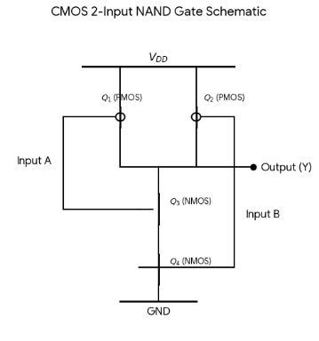
The CMOS implementation of a 2-input NAND gate utilizes four metal-oxide-semiconductor (MOS) transistors: two complementary pairs consisting of two PMOS transistors connected in parallel in the Pull-Up Network (PUN), and two NMOS transistors connected in series in the Pull-Down Network (PDN).

1. Circuit Construction & Schematic
- Pull-Up Network (PUN): Two PMOS transistors (\(Q_{1}\) and \(Q_{2}\)) are connected in parallel between the supply voltage (\(V_{DD}\)) and the output terminal (\(Y\)).
- Pull-Down Network (PDN): Two NMOS transistors (\(Q_{3}\) and \(Q_{4}\)) are connected in series between the output terminal (\(Y\)) and ground (\(GND\)).

2. Behavioral Inference & Simulation Analysis
The state of each MOS transistor changes based on the digital logic levels Applied to inputs \(A\) and \(B\):
- Logic 0 (Low / \(GND\)): Activates a PMOS transistor (creates a closed switch path) and turns off an NMOS transistor (open circuit).
- Logic 1 (High / \(V_{DD}\)): Deactivates a PMOS transistor (open circuit) and turns on an NMOS transistor (closed switch path).
Operational State Breakdown:
- When \(A = 0, B = 0\): Both PMOS transistors (\(Q_1, Q_2\)) are turned ON, creating two parallel connections to \(V_{DD}\). Both NMOS transistors (\(Q_3, Q_4\)) are turned OFF, cutting off the path to \(GND\). The output is pulled High (1).
- When \(A = 0, B = 1\): PMOS \(Q_{1}\) is ON and \(Q_{2}\) is OFF, keeping a low-resistance path to \(V_{DD}\). In the series network, NMOS \(Q_{3}\) is OFF, breaking the path to ground even though \(Q_{4}\) is ON. The output remains High (1).
- When \(A = 1, B = 0\): PMOS \(Q_{1}\) is OFF and \(Q_{2}\) is ON, continuing to connect the output to \(V_{DD}\). In the series network, NMOS \(Q_{4}\) is OFF, blocking conduction to ground. The output remains High (1).
- When \(A = 1, B = 1\): Both PMOS transistors (\(Q_1, Q_2\)) are turned OFF, disconnecting the supply network. Both NMOS transistors (\(Q_3, Q_4\)) are turned ON, establishing a complete conduction path to ground. The output is pulled down to Low (0).

3. Truth Table & Logical Operation
The logical behavior of this complementary construction corresponds precisely to the Boolean function:
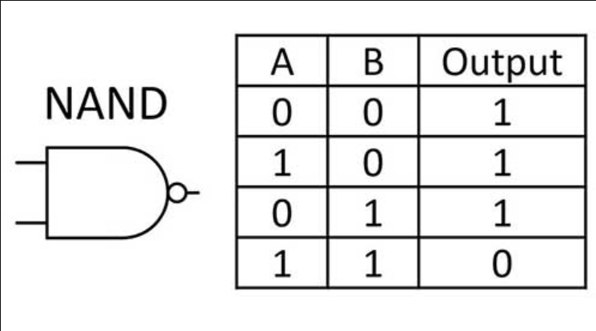
Conclusion: The output is 0 if and only if both inputs are 1. For all other input configurations, the output remains 1, satisfying the logic requirements of a standard universal NAND gate.

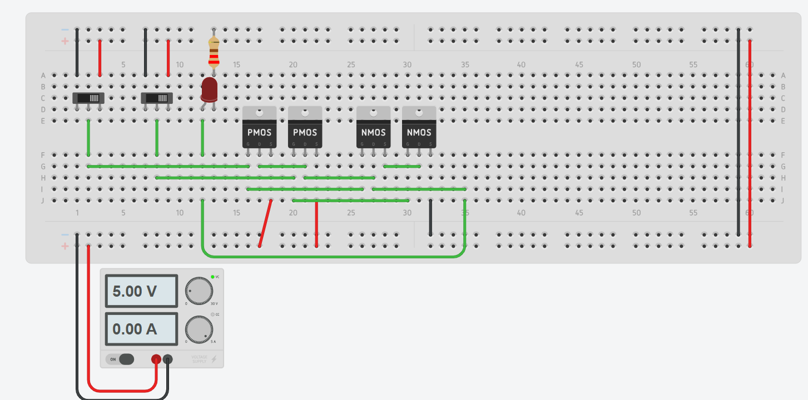
If both are inactive

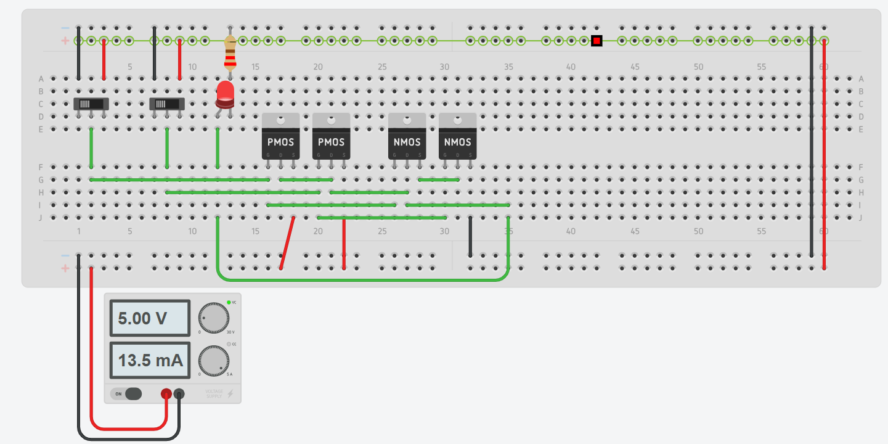
If both are active

